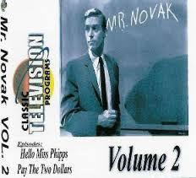 | Mr. Novak: A Television Series  (& A Life in Education)  by  Chuck Harter and John Taylor | 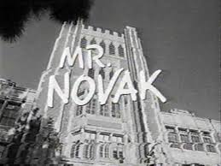
Request to be a Mr. Novak Project Collaborator
Name: ________________________________________
School/College: ________________________________________
Current Position:_______________________________________
Years Teaching Secondary School: ____years
Subject(s): ______________________________________________
Years Teaching Elementary School: ____years
Years Teaching Higher Education: ____years
Mailing Address:
______________________________________________
______________________________________________
Land Phone#: _______________________________
Cell Phone#: ______________________________

Mr. Novak Web Site: http://www.fscj.me /MrNovak/mrnovak.html

