Pathway 4: Chapter 1 Homework/Study Pack
Sample Chapter 1 Exam
Part A: Significant Figures Answers
Part B: Math with Significant Figures Answers
Part C. Scientific Notation Answers
Part D. Metric System & Metric Prefixes Answers
Part E. Metric System Equivalences Answers
Part F. Unit Analysis/Dimensional Analysis Answers Pretest #2 Ans2 Online Site
Part S. Scientific Method
Part V. Chapter 1 Vocabulary Answers
Part M. Multiple Choice
Part Z. Conceptual Chemistry Spotlight: Chapter 1: Global Climate Change
Projects Required (Chapter 1):
Project #2 Measurement via Gasoline Project (due August 19th)
Project #24. The Controlled Experiment Demonstration (due June 19th)
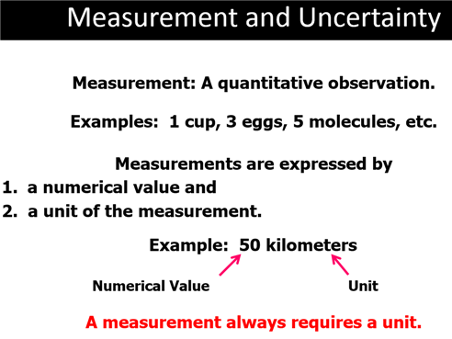
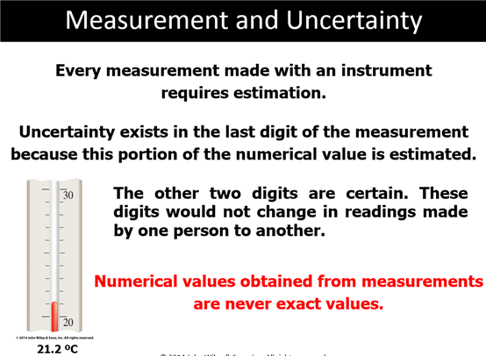
Part A: Significant figures Sample Exam Answers Answers
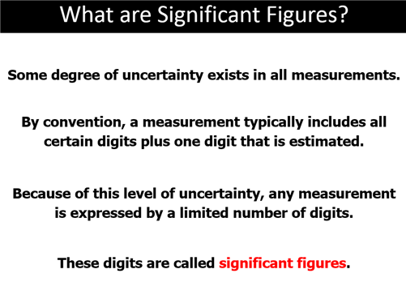
For a very detailed Explanetion of Significant Figues in the Laboartory:
Significant Figures Handout (6 pages)(click to download WIORD .doc file)
or View online:
http://www.northcampus.net/CHM1025/Lab/SignificantFiguresintheLaboratorySP2012.htm
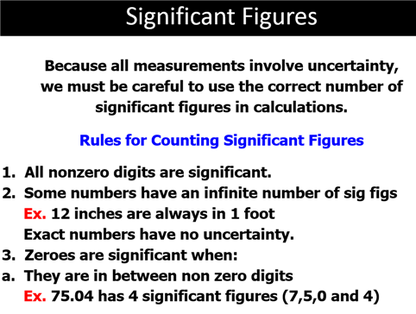
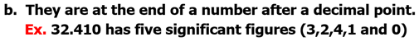
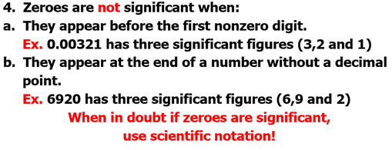
Significant Digit Animation:
http://www.lsua.info/chem1001/Chap2-3Movies/sigdigit.html
John Suchocki Video:
1.6 b. Scientific Figures (Conceptual Chemistry 5th Appendix B)
Video #CO106c (8:04 Minutes)
Mobile/Cell Phone Link: http://bcove.me/xlhukfnu

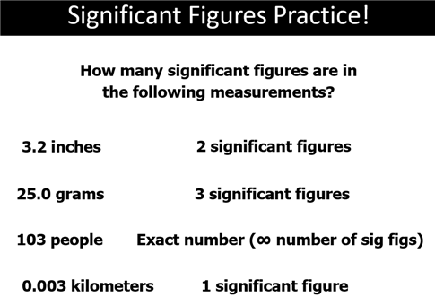
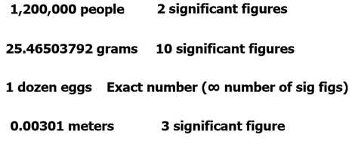
Path 4 Part A Sample Exam Sample Exam Answers:
In the blank, state the number of significant figures in each of the following measurements:
____1. 0.05 mL
____2. 250.0 cm
____3. 456,000,000 people
_____4. 1000 g
_____5. 0.00006500 moles
_____6. 0.00200 kg
_____7. 50 seconds
_____8. 50.0 Seconds
_____9. 50.00 Seconds
_____10. 0.05 Seconds

Part B: Rounding Off & Arithmetic Operations of Sig. Figures Answers

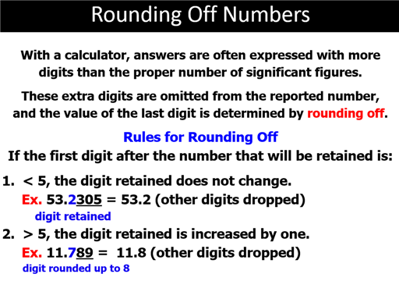

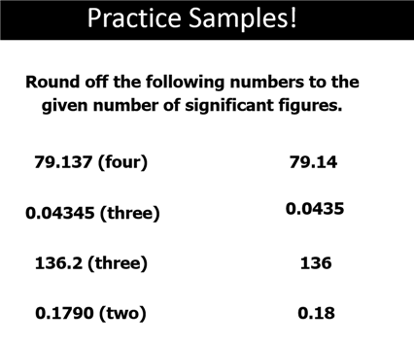
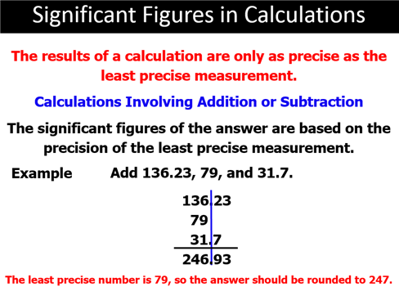

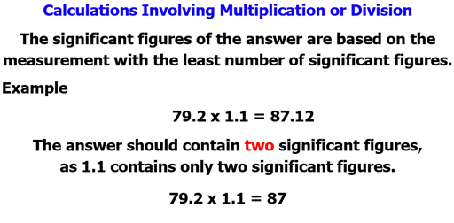

Part B: Rounding Off & Arithmetic Operations of Sig. Figures Answers
Round off the following numbers to three significant figures:

(1) 1.598 x 10⁶ = _____________

(2) 0.000 000 484 500 = _________________

(3) 0.01045 = _______________

(4) 1.98754 X10⁻⁷ = ________________

Perform the following addition/subtraction/multiplication/division operations and express the answer using the proper units and significant figures:

(5) 4 mL
16.3 mL
+ 0.953 mL

(6) 376.5 mL
- 76 mL

(7) 16.5 cm
X 1.7 cm

(8) 12.0 g ÷ 1.00 g =
or
12.0 g / 1.00 g =

(9) 9.2 cm X 9.20 cm X 3.14 X 22.65cm =

(10) (5398 cm³ – 2060.2 cm³) /16.8 cm³/sphere =

Path 4 Chapter 2 Part C: Exponential Numbers and Scientific Notation Answers
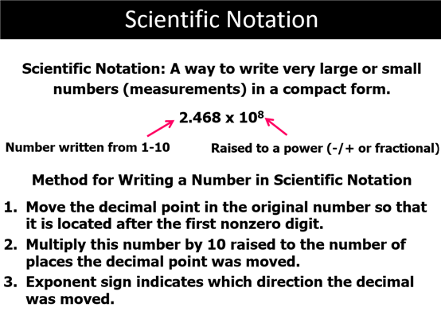

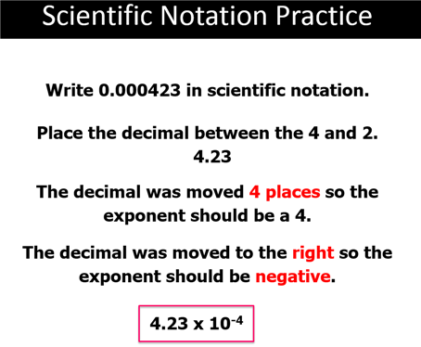
John Suchocki Video:
Video 1.6 a. Scientific Notation (Conceptual Chemistry 5th Appendix A)
Video #CO106b (7:31 Minutes);
Mobile/Cell Phone Link: http://bcove.me/0p5ffj0f

Path 4 Chapter 2 Part C: Exponential Numbers and Scientific Notation Answers
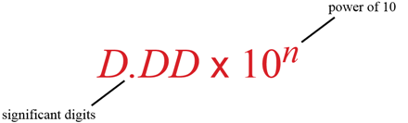

Express the following ordinary numbers in scientific notation (If greater than three significant figures, round off to three significant figures:

(1) 1,010,100,000,000, 000 = ________________

(2) 0.000 000 000 000 019 = ________________

(3) 456,789 = _________________

(4) 0.0001198 = _____________

(5) 1,000,000 = ______________

(6) 0.000200 = ______________

(7) Express the following products in exponential form

2 X 2 X 2 X 2 X 2 X 2 X 2 X 2 = ______________

(8) and use your calculator to calculate the value:

Value = ___________________

(9) Express the following powers often notation:

1 x 10⁰ = ______ 1 X 10¹=______ 1 x 10⁻¹ = _________

(10) Express the ordinary number in scientific notation in three significant figures:

60,230,000,000,000,000,000,000 = _______________________

Path 4 Part D: Metric System Basic Units/Numerical Prefixes Answers
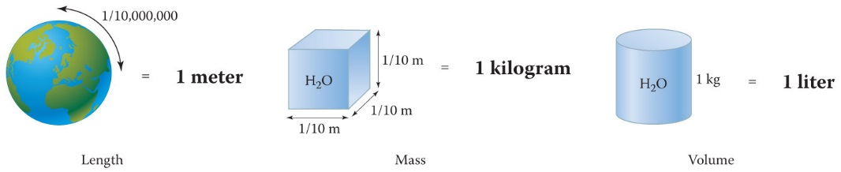
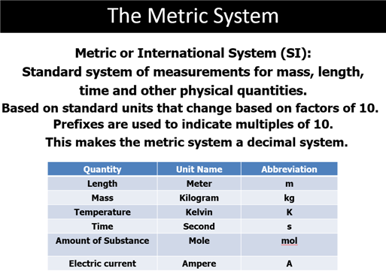

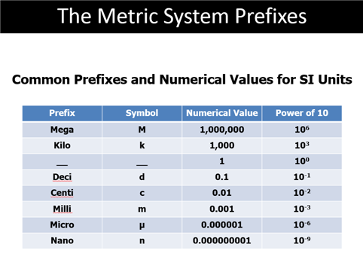
John Suchocki Video:
Video 1.6 d. Metric Prefixes (Conceptual Chemistry 5th Appendix B)
Video #CO106c (7.10 Minutes)
Mobile/Cell Phone Link: http://bcove.me/bnei9533
Path 4 Chapter 1 Part D: Metric System Basic Units/Numerical Prefixes
Fill in the blank with the proper basic unit or metric prefix, then in the parenthesis put the unit’s or
prefix’s abbreviation (Use table from Chapter 3): Answers
____________( ) 1. Basic unit of length in the metric system

____________( ) 2. Basic unit of volume in the metric system

____________( ) 3. Basic unit of mass in the metric system (not SI)

__________( ) 4. Metric prefix which means 1/1000 of a unit

__________( ) 5. Metric prefix which means 1000 units

__________( ) 6. Metric prefix which means 1/100 of a unit

__________( ) 7. Metric prefix which means 1/10 of a unit

__________( ) 8. Metric prefix which means 1,000,000 units

__________( ) 9. Metric prefix which means 1/1000000 ( 10⁻⁶) of a unit

__________( ) 10. Metric Prefix which means 1/1000000000 ( 10⁻⁹) of a unit

Metric Prefix Table:
http://www.lsua.info/MetricSystem/MetricPrefix.html

Metric System Animation:
http://www.lsua.info/chem1001/Chap2-3Movies/metric.html

Path 4 Chapter 1 Part E Metric Unit Factors Answers
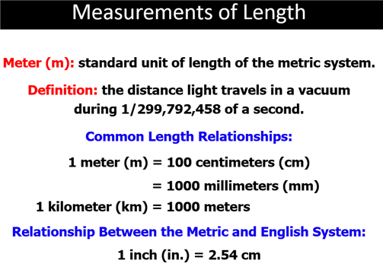
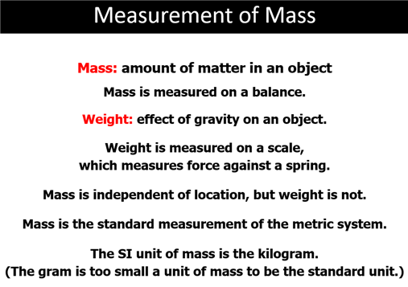
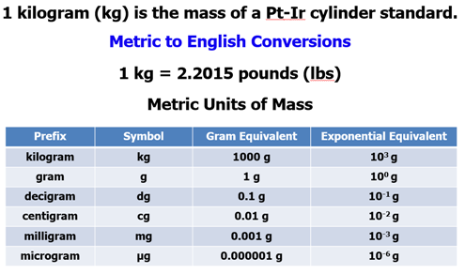
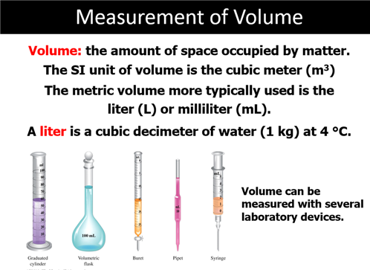
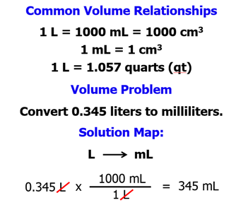
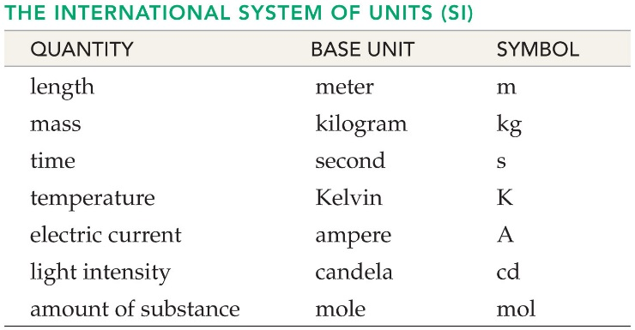

Path 4 Chapter 2 Part E Metric Unit Factors Answers
Fill in the blank with the number which completes the metric unit factor:

(1) __________mg = 1.000 g

(2) __________mg = 1.000 kg

(3) __________mL = 1.000 L

(4) __________cm = 1.000 m

(5) ___________mL = 1.00 cm³

(6) ____________km = 1.000 m

(7) ____________ g = 1 kg

(8) ____________ cm = 1 dm

(9) ___________ µL = 1 L

(10) __________ nm = 1 m
(11) Write a unit equation for each of the following metric equivalents:

- M and Tm (b) L and mL (c) Bytes and Gbytes
- ______________ (b) ____________ (c) ________________
Path 4 Chapter 1 Part F: Unit Analysis Problems
Sample Problem Answers Pretest #2 Ans2 Online Site
Step by Step Unit Analysis Web Site:
http://www.lsua.info/chem1001/dimanalysis/unitanalysisIntro.htm
Dimensional Analysis Animation (Shockwave Plug in Required)
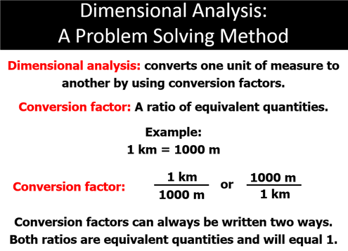
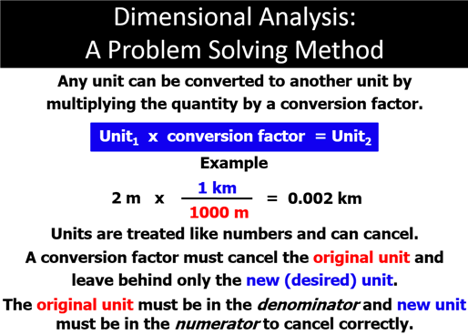
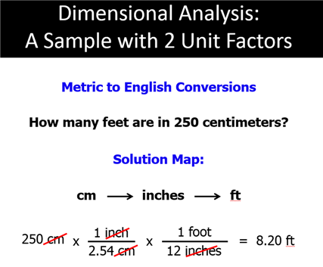
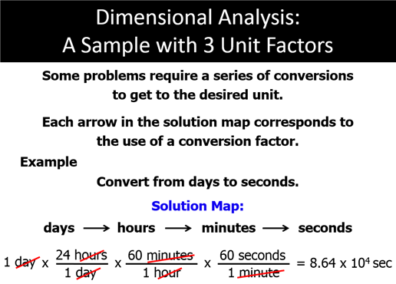
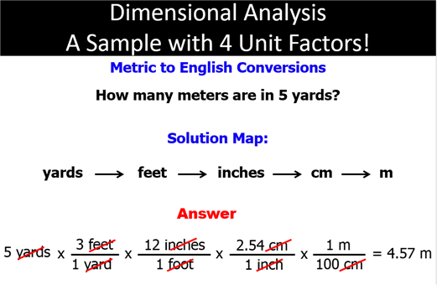

Online Dimensional Analysis Web Site & Interactive DA Calculator:
http://www.lsua.info/chem1001/dimanalysis/unitanalysisIntro.htm
John Suchocki Video:
Video 1.6 d c. Unit Analysis
Video # CO106a (5:26 Minutes)
Mobile/Cell Phone Link: http://bcove.me/anfsogbq

Path 4 Chapter 1 Part F: Unit Analysis Problems Answers Pretest #2 Ans2 Online Site
(When you work you must show dimensional analysis sequence)
Online Dimensional Analysis Web Site & Interactive DA Calculator:
http://www.lsua.info/chem1001/dimanalysis/unitanalysisIntro.htm
Apply the unit analysis method of problem solving to each of the following
(If greater than three significant figures round off to three significant figures):
Problem 1
An oxygen molecule travels 975 mi/hr at room temperature. There are 5280 ft = 1 mi; 12 in = 1 ft,
2.54 cm = 1 in, 1.6 km = 1 mi, and 3600 sec = 1 hr. What is the velocity in meters per second?

Problem 2
If one gram is equal to 15.4 grains. How many 5.00 grain aspirin tablets may be made from 1.00 kilogram of aspirin?

Problem 3
A parsec is the distance light travels in 3.26 years. Given the velocity of light, 3.00 x 10⁸ m/sec,
how many kilometers does light travel in one parsec?

Problem 4
I have 1400 radio programs I want to put on an Apple Ipod. Each program requires 5 megabytes of disk space.
If there are 1024 megabytes in a gigabyte. How many gigabytes of disk space do I need minimum to store
all my programs on the IPod. The Mini-Ipod holds only 4 gigabytes of recordings, could I use a mini for my project?

Step by Step Answers to Problems #1-#4:
http://www.lsua.info/chem1001/dimanalysis/01m2fsampleAns2.html
John Suchocki Video:
1.6 c. Unit Conversion (Conceptual Chemistry 5th Appendix B)
Video #CO106c (5.26 Minutes)
Mobile/Cell Phone Link: http://bcove.me/anfsogbq

Additional Videos Online Menu:
http://www.fscj.me/chm1025/Video/Chapter2VideoMenu.html

Additional Unit Analysis Problems

Problem 5
Find the mass in grains of a 325 milligram aspirin tablet.
(Given: 1.00 g = 15.4 grains)

Problem 6
Insurance statistics state that a person loses 8 minutes of average life for each cigarette
smoked. If there are 20 cigarettes in a pack and the average cost of cigarette is
$5.00 per pack over the next 25 years, how many years of average life would
a person lose for smoking 1.5 packs a day for 25 years?

Problem 7
What is the density of water in lb/ft³, if the density of water at 25ºC is 1.00 g/ml?
[Hint: There are 2.54 cm = 1 in (or 16.48 cm3 = 1 in³); 454 g = 1 lb ]

Problem 8
Calculate the velocity of a car traveling car traveling 65 miles/hr in ft/sec.

More Additional Unit Analysis Problems
Problem 9
How many milligrams does a 0.750 carat diamond weigh?
(Hint: 1 carat = 0.200 g)

Problem 10
Diamond has a density of 3.513 g/cm³. The mass of a diamond is often measured in carats,
1 carat equaling 0.200 g. What is the volume of a 1.50 carat diamond?

Problem 11
Liquor used to be sold in fifths. A fifth is one fifth of a gallon. A gallon is 128 fluid ounces.
Today liquor is sold in bottle sizes of 750 ml to equate to the old fifth. If there are
946 ml in a quart, calculate the number of milliliters in a fifth. How many milliliters
difference is there in the bottling?

Setup and Answers to Problems #1-#12:
http://www.fscj.me/chm1025/sampletest/25M2fSampleAnswer.html

The Ultimate Word Problem with too many numbers which are not needed:

The True Story
On July 23, 1983, Air Canada Flight 143 was flying at an altitude of 26,000 ft from Montreal to Edmonton.
Warning buzzers sounded in the cockpit of the Boeing 767. One of the world's larger planes was now
a glider-the plane had ran out of fuel! Like all Boeing 767s, the plane had a sophisticated fuel gauge,
but it was not working properly. However, the plane was still allowed to fly, because there is an alternate
method for determining fuel. The Mechanics have a dip stick, calibrated in centimeters, and translated
into volume in liters. The Mechanics calculated the three tanks had a total of 7682L of fuel. Pilots always
calculate fuel quantities in mass, because they need to know the total mass of the plane before takeoff.
Air Canada pilots had always calculated the mass in pounds, but the new 767s fuel consumption was
given in kilograms. This involved using the fuel's density to convert 7682 L to a mass in kilograms,
so that the pilot could calculate the mass of fuel that had to be added. The First Officer of the plane
asked the Mechanic for the conversion factor to calculate volume-to-mass conversion, and the
Mechanic replied "1.77". Using that number, the officer and the Mechanic calculated that 4917 L of fuel
should be added. The required amount for the trip was 22,300 kg. The mechanic never gave the First Office
r the conversion units which was for pounds per liter, not kg/liter as the First Officer assumed. The rest of the
story is that the Pilot could not make it to the nearest airport, Winnipeg, but to a little town Gimli which
had a former Royal Canadian Air Force runway converted to a race track. For 30 minutes the plane glided
to Gimil and managed to land.
Now the Problem 12
The Gimli Glider was a Boeing 767 that ran out of fuel. Read the story above, then verify that the ground crew
should have added 20,163 L of fuel instead 4916. The crucial piece of information is the density of the fuel.
The crew used 1.77, but did not recognize the units were pounds per liter. To solve the problem, you need
first to find the density in units of kilograms per liter (Hint: 1 lb = 453.6 grams).

Problem Reworded

Problem 12
12. On July 23, 1983 Air Canada Flight 143, flying at 26,000 feet from Montreal to Edmonton,
ran out of fuel because the first officer asked the mechanic for the conversion factor of
mass to volume at Montreal. The mechanic gave the first officer the answer 1.77
with no units. The plane had 7682 L of fuel at Montreal. The pilot knew he needed
22,300 kg of fuel to make the trip. The mechanic's answer of 1.77 was
pounds per liter not kilograms per liter caused the error such that only
4917 L of fuel was added. If there are 2.205 pounds in a kilogram, how many liters
of fuel were needed for the trip? How many liters minimum of fuel should
have been added at Montreal before takeoff?
Setup and Answers to Problems #1-#12:
http://www.fscj.me/chm1025/sampletest/25M2fSampleAnswer.html

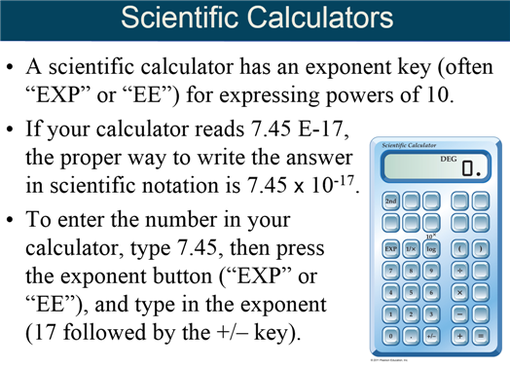

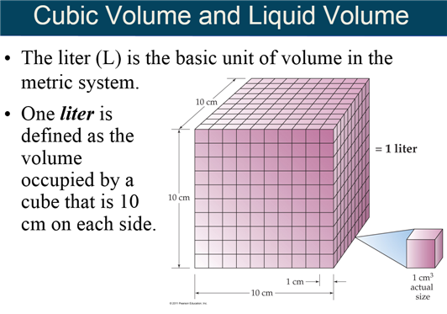

Path 4 Chapter 1 Part S: The Scientific Method
Good Flow Chart:
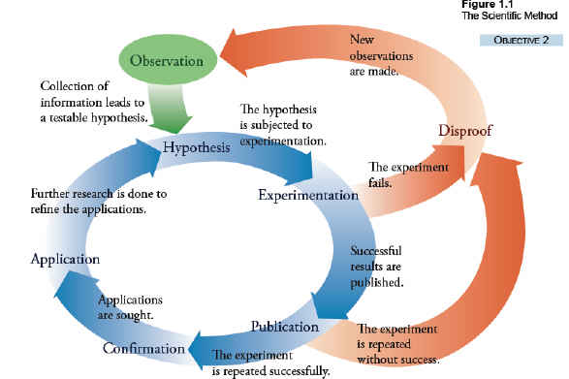
The scientific method consists of:
- Observation of an odd, unusual, interesting event.
- Developing a hypothesis, a tentative proposal of a scientific principle to explain the observation.
- Developing a plan for making observations under CONTROLLED conditions, conducting a planned experiment.
- Refining the hypothesis after analysis of collected experimental data.
- Test refined hypothesis with additional experimentation or altered experimentation.
- If sufficient evidence is gathered by repeated experimentation, the hypothesis, if of a measurable mathematical relationship becomes a natural law. Otherwise it remains a hypothesis.
- A theory is proposed to explain in a broad sense a collection of natural laws and hypothesis. The theory gives the best explanation at that point for a grouping of natural laws and hypothesis
Theories are seldom finished and are generally refined to a higher level of confidence as new data and better observation tools are developed. As an example, the Greeks developed the first atomic theory and John Dalton refined the theory as a hypothesis which has continued to be refined into the current state of modern atomic theory. The scientific method is never a finished process but one that is continuously improving the explanation of nature’s behavior as methods and instruments improve.

Simple Scientific Method Steps (Corwin 7th)
Step 1: Perform a planned experiment, make observations, and record data.
Step 2: Analyze the data and propose a tentative hypothesis to explain the experimental observations.
Step 3: Conduct additional experiments to test the hypothesis. If the evidence supports the initial proposal, the hypothesis may become a scientific theory
- After sufficient evidence, a hypothesis becomes a scientific theory.
- A natural law states a measurable relationship.
Corwin’s Simple Scientific Method Flow Chart:
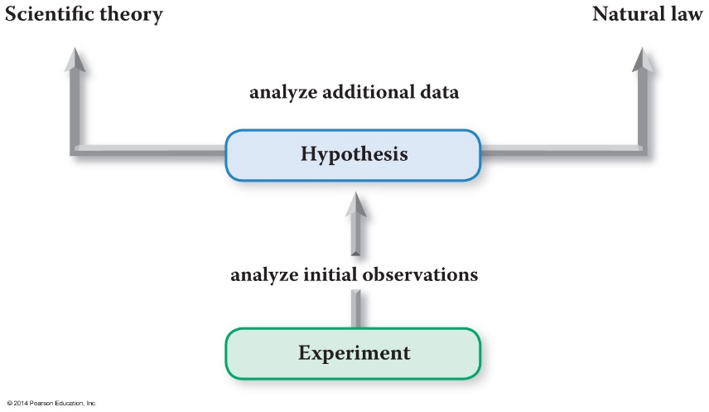
Scientific Method Four Steps (Hein 15th)
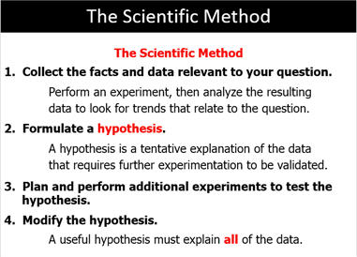

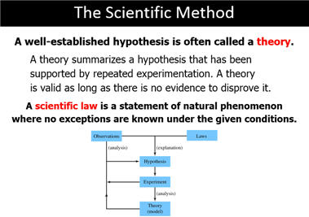
Learning Chemistry
- Different people learn chemistry differently.
- What do you see in the picture?
- Some people see a vase on
a dark background; some people see two faces.
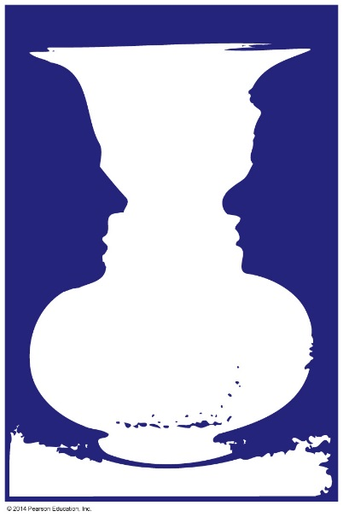
What Do You See? A Vase or Two Faces

Chapter 1 Part S: The Nine Penny Problem (Background)
Over the years the United States Ming has changed the ratio of different metals used in making the various coins. The last change for the penny occurred in 1982. It is estimated that there are 200 billion pennies in current circulation.
Following is a brief chronology of the metal composition of the one-cent coin (penny):
- From 1793 to 1837, pure copper.
- From 1837 to 1857, bronze (95 percent copper, five percent tin and zinc).
- From 1857 to 1864, 88 percent copper and 12 percent nickel, giving the coin a whitish appearance.
- From 1864 to 1962, bronze (95 percent copper, five percent tin and zinc). Known as the wheat penny Mass 3.100 grams
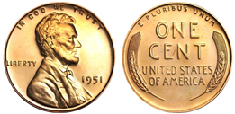
- (In 1943, most cents were made of zinc-coated steel because of the critical use of copper for the war effort. However, some copper pennies were minted that year, known as the zinc penny.) Worth 10-13 cents circulated-A student stole my 50 steel penny collection used for lab experiment.
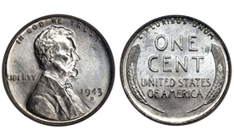
- 1962 to 1982, 95 percent copper and 5 percent zinc (the tin was removed).Mass: 3.100 g
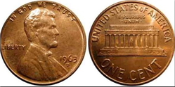
- Since 1982, 97.5 percent zinc and 2.5 percent copper (copper-plated zinc). Cents of both compositions appeared in the first year.
Current Penny:  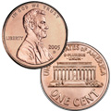 | Specifications:  Composition:  Copper-Plated Zinc: 2.5% Cu, Balance: Zn 97.5 %  Mass: 2.500 g  Diameter: 0.750 in., 19.05 mm  Thickness: 1.55 mm Edge: Plain

Legislation
In 1990, United States Representative Jim Kolbe (R-AZ) introduced the Price Rounding Act of 1989, HR 3761 to eliminate the penny in cash transactions, rounding to the nearest nickel.^{[3]} In 2001, Kolbe introduced the Legal Tender Modernization Act of 2001, HR 5818,^{[4]} and in 2006, he introduced the Currency Overhaul for an Industrious Nation (COIN) Act, HR 5818.^{[5]} While the bills received much popular support from the public, and therefore from their representatives, the bills were not made to law when Congress adjourned.^{[6]} There are public pressures on many Representatives to reintroduce these bills to the legislature. One such example is the constituency of the 2nd District of Colorado, represented by Jared Polis.^{[7]}

Arguments for elimination
- Production at a loss – As of 2015, it costs about 1.4 cents to mint a penny.^{[8]} In 2007, the price of the raw materials from which it was made exceeded the face value, so there was a risk that coins were illegally melted down for raw materials.^{[9]}
- Lost productivity and opportunity cost of use – With the median wage in the US being about $17 per hour in 2011,^{[10]} it takes about two seconds to earn one cent. Thus, it is not worthwhile for most people to deal with a penny. If it takes only two seconds extra for each transaction that uses a penny, the cost of time wasted in the US is about $3.65 per person annually,^{[11]} about $1 billion for all of the US.^{[12]} Using a different calculation, economist Robert Whaples estimates a $900 million annual loss.^{[13]} Additionally, Whaples argues that eliminating the penny would coax people into using $1-coins. The Federal Reserve says that replacing $1 bills with $1 coins would save an additional $500 million a year.^{[14]}
- Limited utility – Pennies are not accepted by all vending machines or many toll booths, and pennies are generally not accepted in bulk. Pennies often end up sitting in jars or are thrown away and are not in circulation.^{[citation needed]} Economist Greg Mankiw says that "The purpose of the monetary system is to facilitate exchange, but... the penny no longer serves that purpose."^{[15]} Pennies are often discarded by consumers and the Mint must produce more of them than all other coins combined.^{[2]}
- Prices would not be higher – Research by Robert Whaples, an economics professor at Wake Forest University, using data on nearly 200,000 transactions from a multi-state convenience store chain shows that rounding would have virtually no effect. Consumers would gain a tiny amount – about ¹⁄₄₀¢ or $0.00025 per transaction.^{[16]}
- Elimination would not hurt the poor^{[17]} – Given that rounding is neutral at the transaction level, and that cash transactions are faster without having to deal with extremely low-value coins, people who disproportionately deal in cash transactions might be helped more by elimination of the penny.
- Historical precedents – There has never been a coin in circulation in the US worth as little as the penny is worth today, although currently other countries have coins with less purchasing power in circulation. Due to monetary inflation, a nickel (5-cent piece) in 2007, was worth approximately what a penny was worth in 1972.^{[18]} When the United States discontinued the half-cent coin in 1857, it had a 2010-equivalent buying power of 11 cents.^{[19][20]} After 1857, the new smallest coin was the cent, which had a 2010-equivalent buying power of 23 cents.^{[20]} The nickel fell below that value in 1974; the dime (at 10 cents) fell below that value in 1982; the quarter (at 25 cents) fell below that value in 2013.^{[18][20]}
- Zinc toxicity – Zinc can cause fatal anemia or gastric ulceration in pets that inadvertently ingest pennies made after 1982.^{[21]}

Arguments for preservation
- Consumers and the economy – Research commissioned by the zinc lobby and its front group Americans for Common Cents concludes that were the penny to be eliminated, consumers might be hit with a "rounding tax". The paper stated that rather than eliminate the penny, it could make more sense to change the composition of the penny to a cheaper metal than zinc if the costs of zinc do not come down and there continues to be a significant loss per penny.^{[22]}
- Popular support – A poll conducted June 9–11, 2006, by USA Today/Gallup, found that 55% of the American public considered the penny to be a useful coin, while 43% of those surveyed were in favor of abolishing the coin.^{[23]}
- Increased cost – A report by Navigant Consulting commissioned by Jarden Zinc, which supplies zinc to the Mint, found that the government would lose money without the penny. According to Americans for Common Cents' website, "First, the Mint's fabrication and distribution costs include fixed components that will continue to be incurred whether or not the Mint produces the penny. Navigant estimates this fixed component at $13 million in FY 2011. Plus, there is $17.7 million in Mint overhead allocated to the penny that would have to be absorbed by the remaining denominations of circulating coins without the penny. Second, under current Mint accounting, the nickel costs eleven cents to manufacture. In a scenario where nickel production doubled without the penny, Navigant concludes that with existing fixed costs, eliminating the penny would likely result in increased net costs to the Mint of $10.9 million, relative to the current state."^{[24][25]}
- Rounding hurts the poor – Millions of transactions are conducted each day in the US economy, and with 26% of Americans either not having savings or checking accounts or relying on payday lending services, there are many cash transactions taking place involving American citizens each day. Federal Reserve studies have shown that people with relatively low incomes use cash more frequently than individuals with higher incomes. Since only cash transactions will be subject to rounding, any move to eliminate the penny may hurt "unbanked" Americans who have no other option and lack the means to make non-cash transactions.^{[26]} Though, Canada's elimination of the penny would round cash transactions both up and down. ^{[27]}
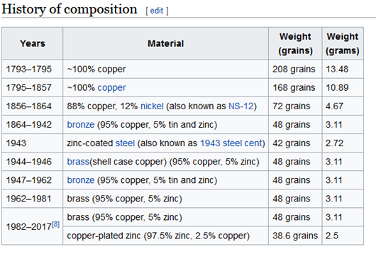

Nine Penny Problem with The Two Pan Balance:
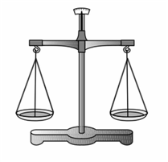
You have nine pennies. Eight of the pennies are post 1982 dated, therefore they weight 2.500 grams eash.
You have one penny with a 1974 mint date and it weighs 3.100 grams.
You need to design and write the directions for an experiment on how you would use the above balance to find 100% of the time, the heavier 1974 penny:
1.Write the directions below as steps Only what is the number of weighing needed in your this procedure below:
Step 1:
Step 2:
Step 3:
Step 4:
Step 5:
Step 6:
Step 7:
Step 8:
How many weighing would use use maximum to sove the problem:
One Two Three Four Five

2. Now rewrite the experiment so that it will take a different Number of weighings
Write the directions below as steps Only what is minimal needed) in you procedure:
Step 1:
Step 2:
Step 3:
Step 4:
Step 5:
Step 6:
Step 7:
Step 8:
How many weighing would use use maximum to sove the problem:
One Two Three Four Five
3. Now try to rewrite the experiment so that it will take a different Number of weighings than #1 or #2

Path 4: Chapter 2 Part S: Scientific Method Sample Test
A. State Three Steps in the Scientific Method according by the Corwin Text:
1.
2.
3.
Fill in the words on the Corwin Simple Scientific Method Flow Chart
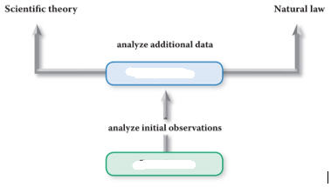
B. State Four Steps in the Scientific Method according by the Hein Text:
1.
2.
3.
4.

Fill in the words on the Hein Simple Scientific Method Flow Chart
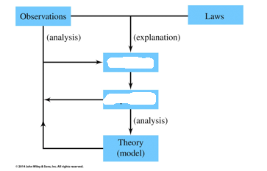

Problem Solving
- Connect the dots using only four straight lines.
Experiment until
you find a solution

- Connect the dots using only four straight lines.
- Experiment until you find a solution.
- Did you have to use five straight lines?
- No matter which dot we start with, we still need five lines.

Path 4 Chapter 1 Part V: Chapter 1 Vocabulary
The following Chapter Vocabulary terms may be found at the end of Chapter 1:
Summer of Terms page 19.
Fill in the blank(s) with the word that best fits the definition (Chapter 1
1. ___________________ A type of research that focuses on developing applications of knowledge
gained through basic research.
2. ___________________ A type of research that leads us to a greater understanding of how the natural world operates.
3. ___________________ The study of matter and the transformations it can undergo.
4. ___________________Something agreed upon by competent observers as being true.
5. ___________________ Anything that has mass and occupies space.
6. ___________________ An area where we engineer materials by manipulating individual atoms or molecules.
7. _______________________A testable explanation for an observable phenomenon.

8. ___________________ A formal statement of a scientific hypothesis that has been
repeatedly tested and supported by experimental data. Also known as a principle.
9. ___________________ A well-tested explanation that unifies a broad range of observations within the natural world
Additional vocabulary terms not in the Chapter 1 Summary:
10___________________A scientific procedure undertaken to make a discovery, test a hypothesis, or demonstrate a known fact.
11. ___________________ is a systematic investigation of nature and requires proposing an explanation for the results of an experiment in the form of a general principle

Part Z. Conceptual Chemistry Spotlight: Chapter 1: Global Climate Change
Reference::
http://www.numericana.com/answer/weighing.htm#birthday
https://upload.wikimedia.org/wikipedia/commons/8/82/False_Coin_Problem.gif

