Pathway 4: Chapter 2 Homework/Study Pack
Sample Chapter 2 Exam
Part A. Atoms
Part B: Density Answers
Part C: Forms of Energy Answers Fig 3.13 Fig 3.14 Fig 3.15 Fig 3.16
Part D. Energy Transformations Answers
Part E. Temperature Conversions Answers
Part F. Properties of Solid, Liquids, and Gases Answers
Part G. Gas Laws Answers
Part G0. Gas Pressure and Calculations
Part G1. Boyles Law of Gases Calculations
Part G2. Charles Law of Gases Calculations
Part G3. Gay-Lussac’s Law of Gases Calculations
Part G4: Dalton Law of Gases Calculations
Part G5. Ideal Gas Law Calculations
Part G6. Avogadro’s Law of Gases Calculations
Part H. Gas Law Calculation Answers
Part K. Kinetic Molecular Theory Answers
Part P. Phase Diagrams Answers
Part V. Chapter 2 Vocabulary
Part M: Chapter 2 Multiple Choice (Blackboard - Course Content-Required Path 2 Quizzes – Chapter 2)
Part Z: Chapter 2 Conceptual Chemistry Spotlight: Green Chemistry

Path 4 Chapter 2 Part A: Atoms (from Chapter 1: the Micron!)
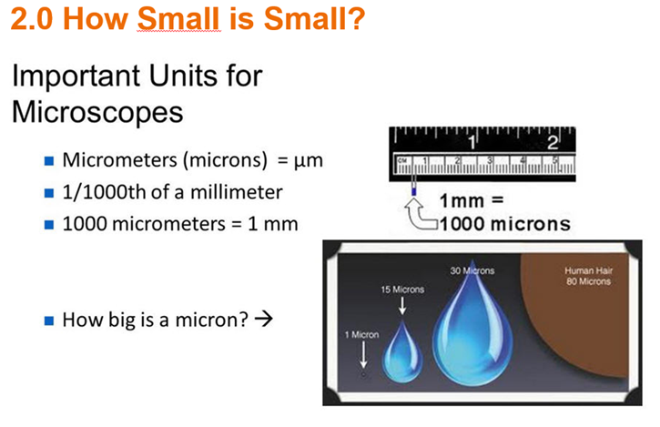
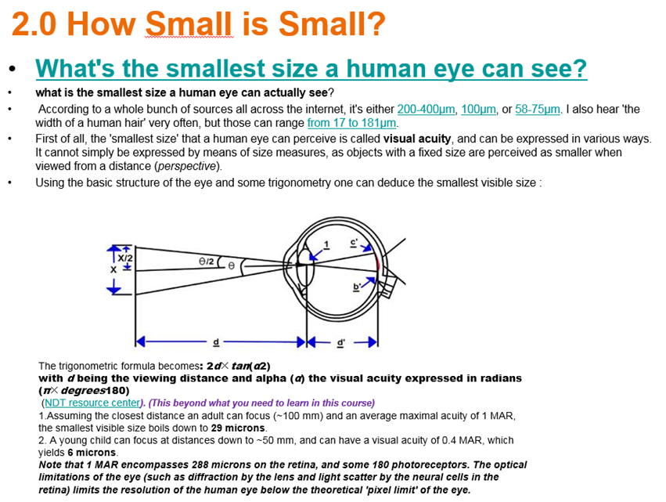

How Small is Small?

Define: Astronomical;

Macroscopic;

Microscopic;

Sub-Microscopic

To Understand Chemistry is to study the three major worlds of matter:
Macroscopic; Sub-microscopic; and Symbolic
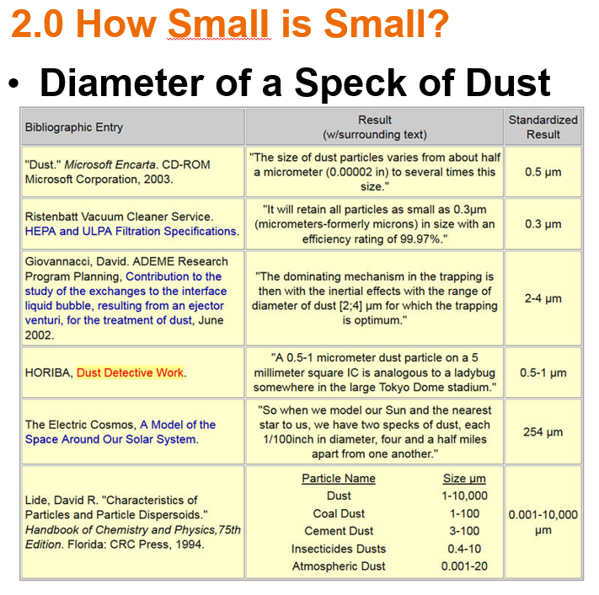
Households spend many hours removing dust from furniture and the air. The size of one of these particles,
which is the cause of problems such as asthma, can be found in the range of several nanometers (10⁻⁹ m)
to just under a millimeter (10⁻³ m). More commonly, however, dust are those particles between
1 and 100 micrometers (10⁻⁶ m).
Three thirds of the sources determined the diameter of a speck of dust to be a small number and/or a range,
but one source referred to the diameter as specifically 254 micrometers. That is odd and may not be
completely accurate. The Handbook of Chemistry and Physics provided the most different answer.
The range of the size of dust was very large and specific to the type of dust.
The dust that fills the air is composed of many things, such as fibers, hairs, pollen, bacteria, and molds.
Large cities also have smoke and tarry soot in their atmospheric dust. They also have a greater
concentrations of dust than in smaller cities or mountainous areas. Dust is a major contributor to
atmospheric pollution but it can also serve as nuclei for the condensation of water vapor into droplets.
Without them, fog, mist and clouds would not exist.
There are also several hazards that can come from dust. When found in high concentration in some
types of mills and mines, they are an explosion hazard. Also, when silica is found in dust, it can ruin
machinery because of how rigid it is and can cause problems if it is inhaled.
Marina Bolotovsky – 2003
What the eye can see and what particles deposit in your lungs:
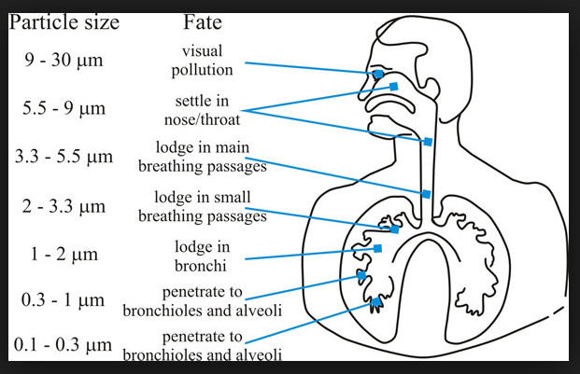
Indoor Air Quality - What You Should Know
Based on studies by the Environmental Protection Agency (EPA), billions
of dollars are spent annually for medication to help Americans breathe or cure their
respiratory illnesses. Eleven million Americans have asthma. Twenty-eight million
have hay fever and other allergies. Physicians are now discovering that the solution
to the problems of many of these people is not in medicine but in reducing
the pollutants in the air they breathe.
Every year at least 6,000 new chemical compounds are developed.
Many are used indoors every day, at home and at work. Add to these pollutants
the mold, mildew, bacteria, viruses, tobacco smoke, grease, pollen, dirt, asbestos,
lead and numerous other contaminants that can affect our breathing and our health.
Then allow them to circulate in today’s nearly airtight indoor environment. No wonder
our indoor air is, on average, two to ten times as polluted as the worst outdoor air.

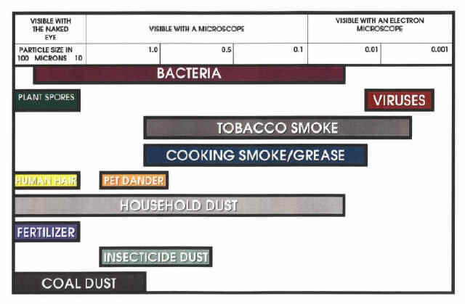
Viruses and bacteria that thrive in the ducts, coils, and recesses of building
ventilation systems have been proven to cause ailments ranging from influenza to
tuberculosis. Some HVAC systems have been found to contain up to 27 species of fungi.
Based on information given at the First Annual Air Quality convention sponsored
by EPA, April 1992, Tampa, Florida:
• 40% of all buildings pose a serious health hazard due to indoor air pollution,
according to the World Health Organization.
• EPA estimates an 18% annual production loss to American business due to poor
indoor air quality.
• 20% of all employees have a major illness related to indoor air pollution
such as allergies, asthma, auto-immune diseases, etc.
• EPA says high levels of formaldehyde cause cancer
• Scientists now recognize that pollutants, even at acceptable concentration,
combined together in an indoor environment have a synergistic negative effect.

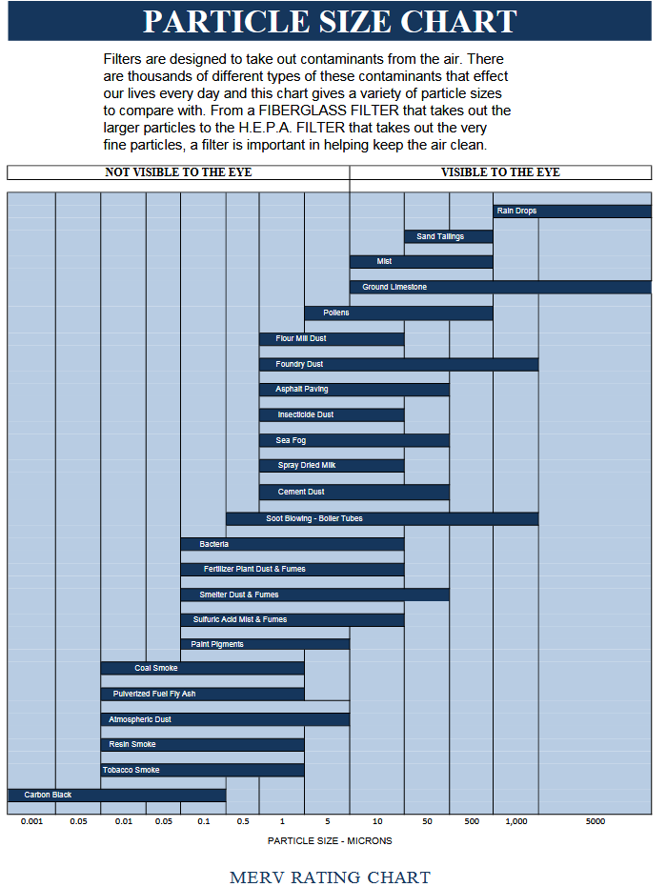

Airborne particles
Airborne particles are solids suspended in the air.

Larger particles - larger then 100 μm
terminal velocities > 0.5 m/s
fall out quickly
includes hail, snow, insect debris, room dust,
soot aggregates, coarse sand, gravel, and sea spray

Medium-size particles - in the range 1 to 100 μm
sedimentation velocities greater than 0.2 m/s
settles out slowly
includes fine ice crystals, pollen, hair, large bacteria,
windblown dust, fly ash, coal dust, silt, fine sand, and small dust

Small particles - less than 1 μm (submicron)
falls slowly, take days to years to settle out of a quiet atmosphere.
In a turbulent atmosphere they may never settle out
can be washed out by water or rain
includes viruses, small bacteria, metallurgical fumes,
soot, oil smoke, tobacco smoke, clay, and fumes

Hazardous Dust Particles
Smaller dust particles can be hazardous for humans. In many jurisdictions dust fractions at specified particle sizes in working environments are required to be measured.

Inhalable Dust
Airborne particles which can enter the nose and mouth during normal breathing. Particles of 100 microns diameter or less.

Thoracic Dust
Particles that will pass through the nose and throat, reaching the lungs. Particles of 10 microns diameter and less. Referred to as PM₁₀ in the USA.

Respirable Dust
Particles that will penetrate into the gas exchange region of the lungs. A hazardous particulate size less than 5 microns. Particle sizes of 2.5 micron (PM_{2.5}) are often used in USA

Particles 101: Did You Know?...
- Visible particles constitute only about 10% of indoor air!
- Particle visibility depends on the eye itself. In other words, light intensity and
quality, background and particle type.
- Particles on furniture and those in a shaft of light are approximately
50 microns or larger.
- It may be possible to see particles as small as 10 microns under favorable conditions.
- The majority of harmful particles are 3 microns or less in size.
- Particles of 1 micron or less adhere to surfaces by molecular adhesion.
Scrubbing is generally the only way to remove them.
- Larger particles tend to settle out of the atmosphere due to weight.
- Smaller, "respirable" particles remain virtually suspended in the air until breathed in.
- Approximately 98-99% of all particles by count are in the size range of 5 microns
or less. These particles tend to remain in suspension or settle out so slowly that
only quality electronic air cleaners and HEPA air cleaners are effective in removing
these particles.
- The average person breathes in about 16,000 quarts of air per day.
Each quart contains some 70,000 visible and invisible particles.
That's over a billion particles per day that our lungs have to filter out!
- The average home collects about 2 pounds of dust per week!
- A 9' x 12' carpet or rug will collect an average of about 10 pounds of dust per year!

How will you filter the air indoors in your home or apartment?

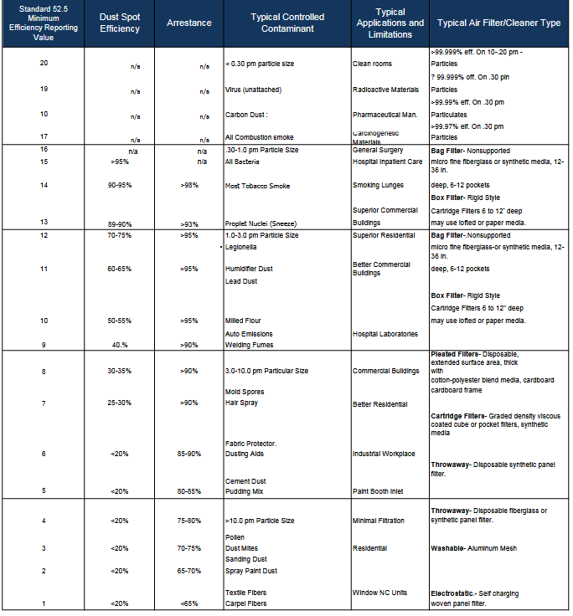

A better chart:

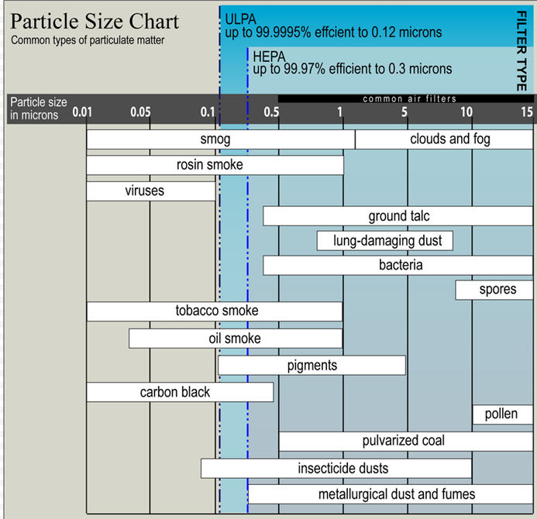

What could you do to prevent mold and viruses in your home?

Why is ozone (O3) a powerful and efficient cleaner and purifier
of indoor air quality?
How do negative ions generation help clean indoor air quality?

The first theory of matter:

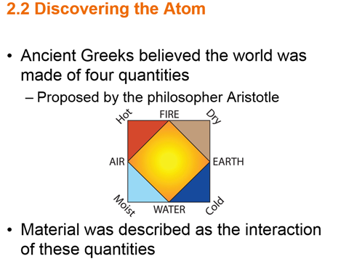
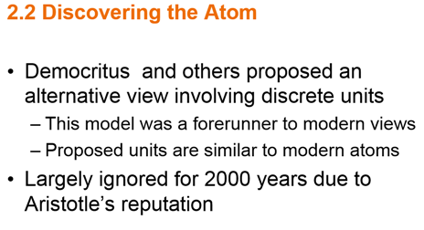

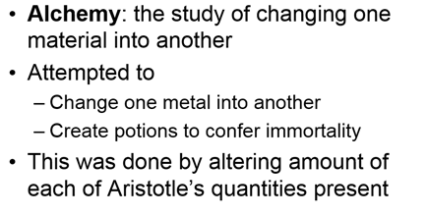

Transmutation Not Possible by Chemical Change (Chapter 9):
Fe to Au
Transmutation Possible by Nuclear Change (Chapter 5)
But Gold was not made from Iron During Nuclear Fusion!

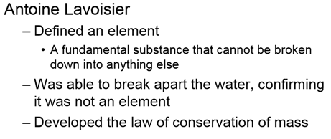
This first chemistry book in French is very hard to read!

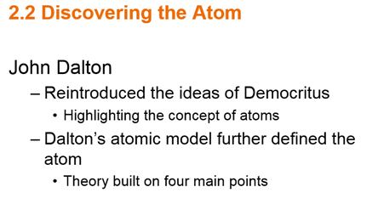

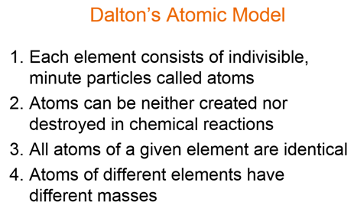
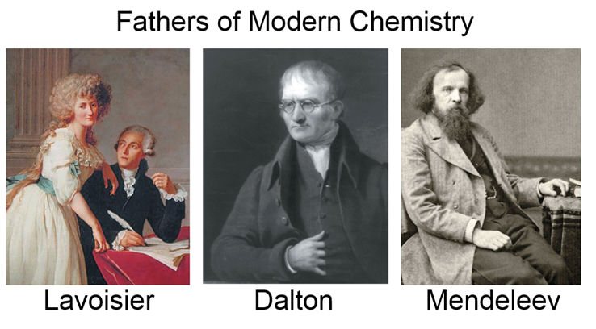

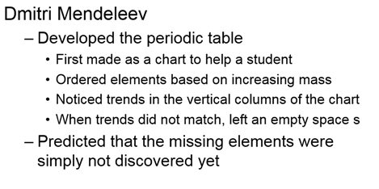
Mendeleev’s Periodic Table
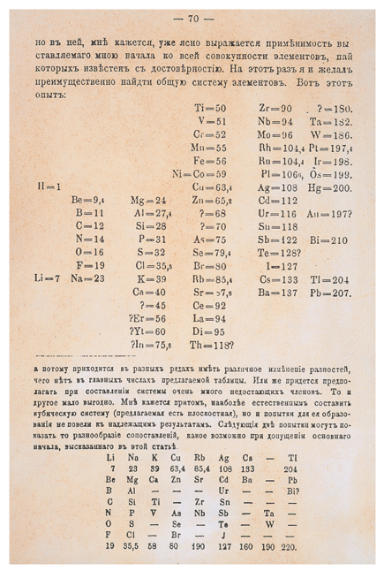
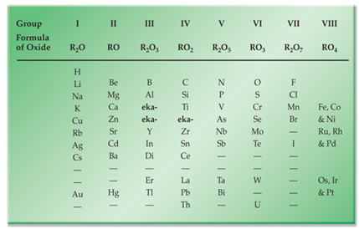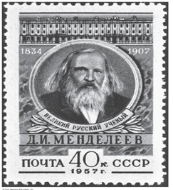
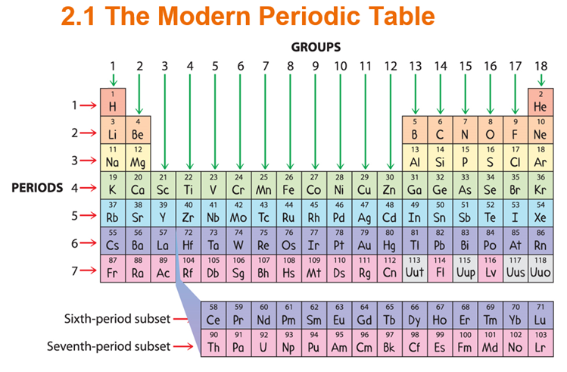
John Suchocki Conceptual Chemistry 5th Edition Videos:
Chapter 2: Particles of Matter
2.1 The Submicroscopic World Is Super-Small (do not click on Video Quiz button)
Submicroscopic (4:56 Minutes)
2.2 Discovering the Atom (do not click on Video Quiz button)
KM: Air Out CO#202a (5:18 minutes) (Optional) http://bcove.me/8a30ohvs

Path 4 Chapter 2 Part A: Atoms Quiz:
Answer questions: !, 2, 25, 38, 44, 45, 83 for Section 2.1 at the end of the chapter
Answer questions: 3 4, 5, 26, 46, 47, 48 49, 85 for section 2.2 at the end of the chapter

Path 4 Chapter 2 Part B: Density, Specific Gravity & Volume Problems Answers
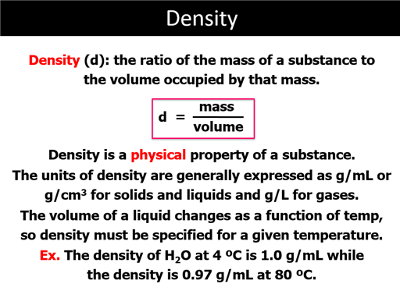
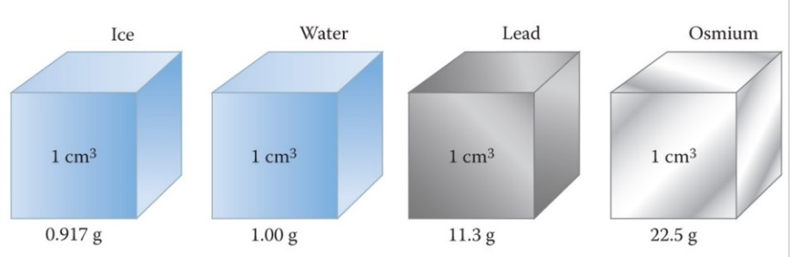
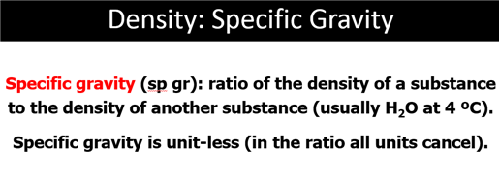
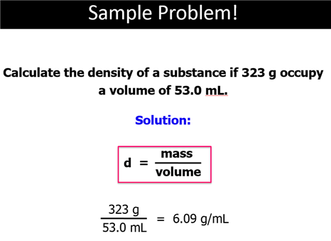
John Suchocki Conceptual Chemistry 5th Edition Videos:
Section 2.3 Mass Is How Much and Volume Is How Spacious (Three videos)
a. Distinguishing Mass, Weight, and Volume CO#203a (10:19 minutes)
b. KM: Penny Fingers CO@303b (2:56 Minutes) http://bcove.me/avuq6dfv
c. KM: Decisive Dimensions CO#203c (2:41 minutes) http://bcove.me/rc9y51mu
Section 2.4 Ways to Think About Density CO#204a (8:06 minutes) http://bcove.me/w6kzb3ms
Path 4 Chapter 2 Part B: Density, Specific Gravity & Volume Problems Answers
1. A quartz rock was cut into a rectangular solid paperweight. IF the paperweight has a mass of 165 g and measures 5.00 cm by 5.00 cm by 25.0 mm, what is its volume in cubic centimeters?

2. Calculate the density in g/mL for 10.0 grams of ethyl ether having a volume 14.0 mL.

Additional Homework (not required) for your practice:
Suchocki 5th Edition:
Section 2.4 Chapter 2 Questions: 9, 10, 32, 33, 54-57

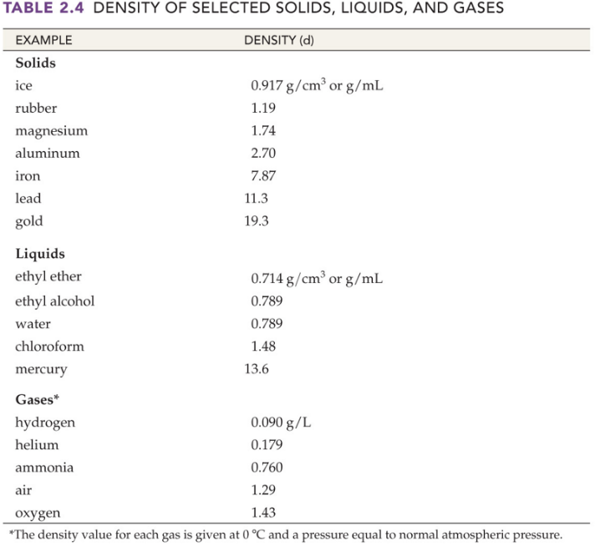 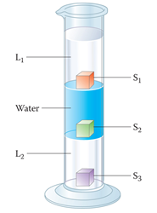
How does the Galileo Thermometer Work?

Path 4 Chapter 2 Sample Test/Homework Packet

Part E: Energy/Forms of Energy
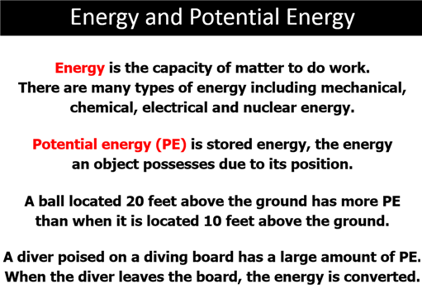
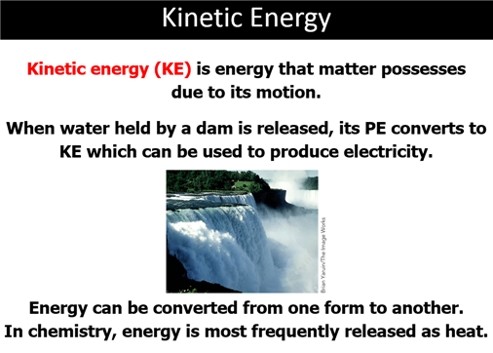

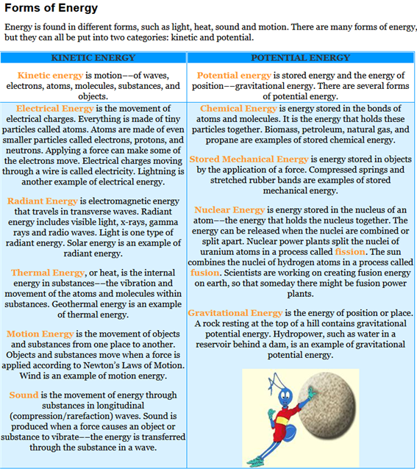
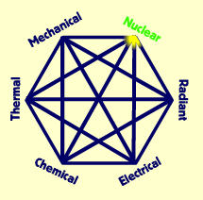
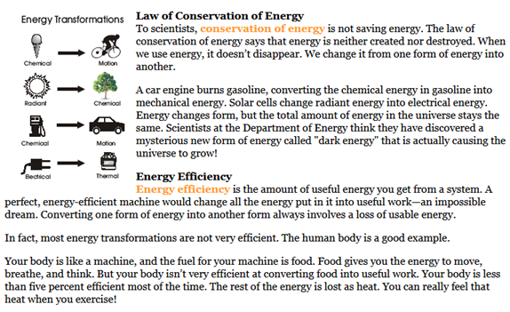
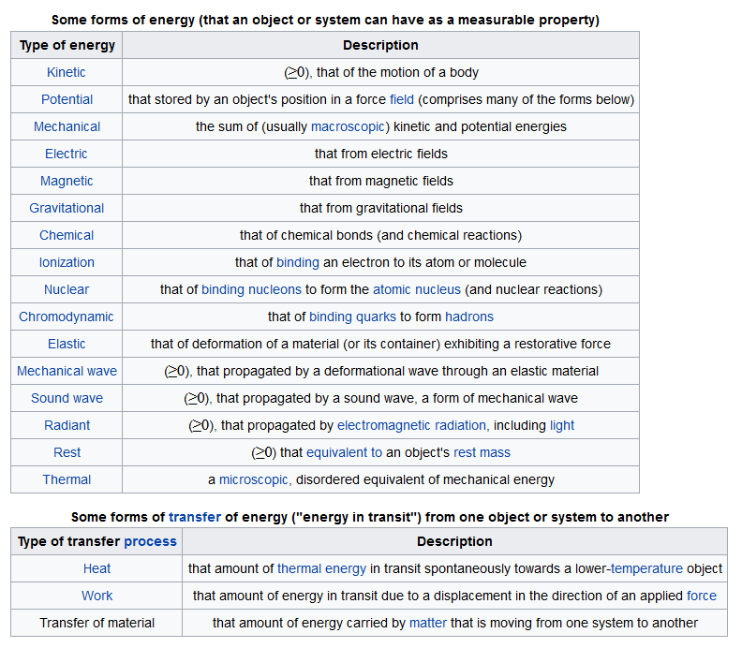
Define Energy:

What is the difference between the two types of energy: potential and kinetic energy?

List the six different forms of energy as an energy wheel as stated in the book:

Define the Law of Conservation of Energy:

Reword the Law of Conservation of Energy into the first law of thermodynamics:

Which state of matter has the lowest kinetic energy?

What is the “Heat Death Theory of the Universe”?

Bonus: define Gravitational Energy; Tidal Energy; Sound Energy; Magnetic Energy; Radiant Energy; Dark Energy

Chapter 2 Sample Test/Homework Packet
Part E1: Energy Transformations 1 point

Identify two forms of energy that are involved in each of the following energy conversions:

- relating to a fossil fuel plant:
a. Burning coal converts water to steam:

b. A turbine spins and drives an electrical generator:

- Solar Hot Water Energy Panels:

- Photovoltaic Solar Energy Panels:

- Radioactive emissions vaporize water into steam

- Identify two forms of energy that are involved in each of the following devices:

- Flashlight

- Solar Calculator

- Lead-acid battery

- Classify the following energy sources as renewable and nonrenewable:
a. Biomass f. Hydropower
b. Petroleum g. Coal
c. Geothermal h. natural gas
d. Wind i. solar
- Uranium j. propane

John Suchocki Video:
1.6 d. Metric Prefixes (Conceptual Chemistry 5th Appendix B)
Video #CO106c (7.10 Minutes)
Mobile/Cell Phone Link: http://bcove.me/bnei9533

Part G Gas Laws

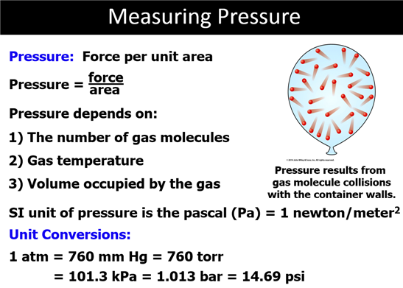

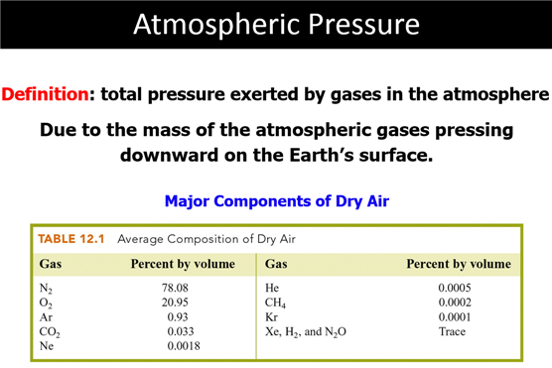

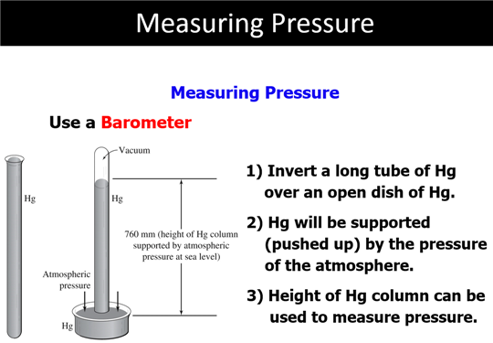

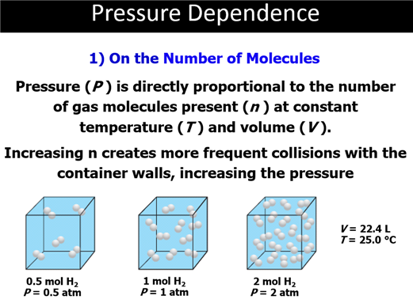
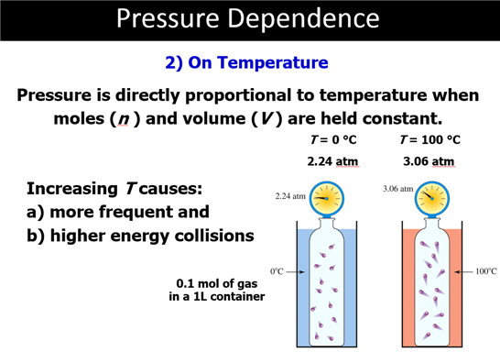
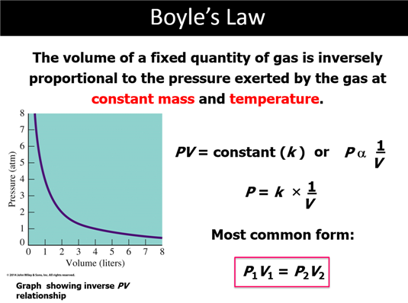
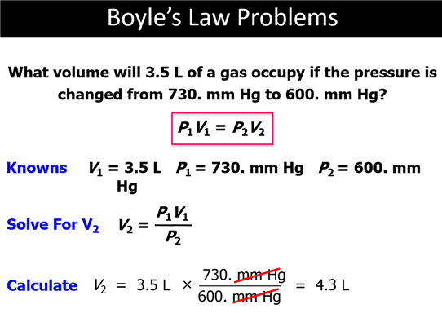
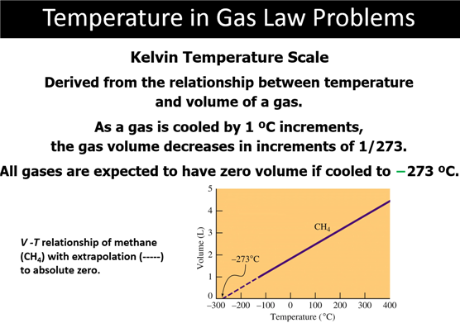
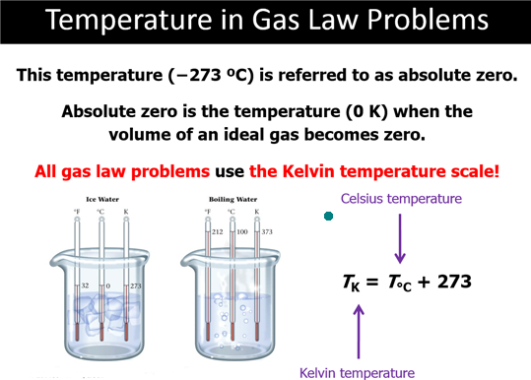
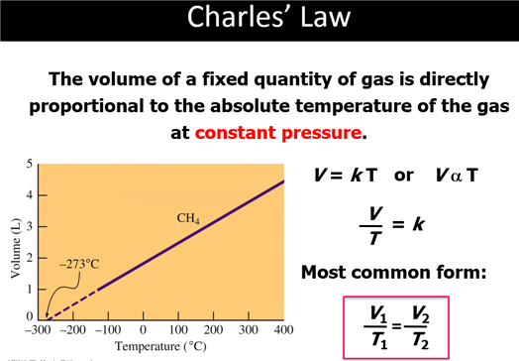
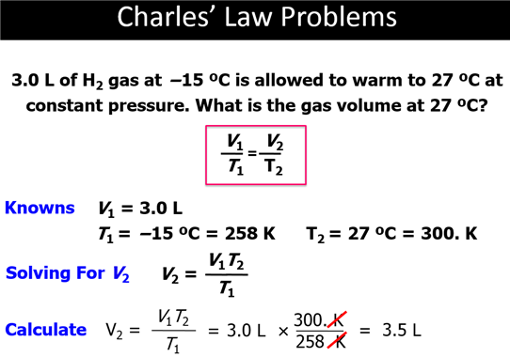

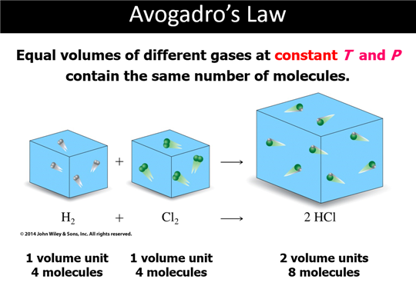
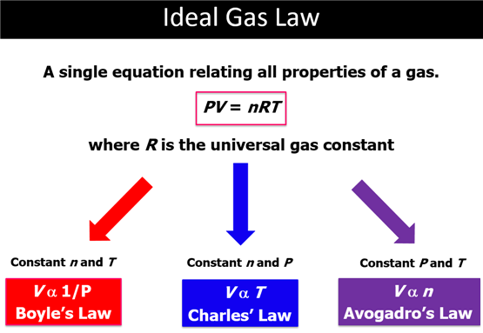
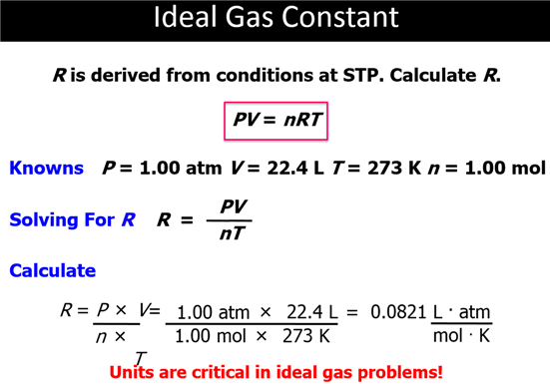

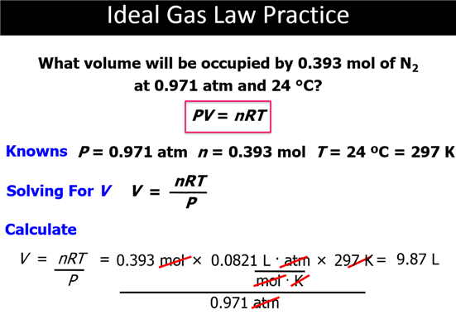
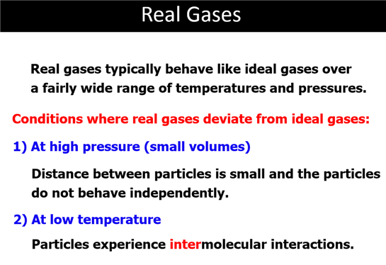
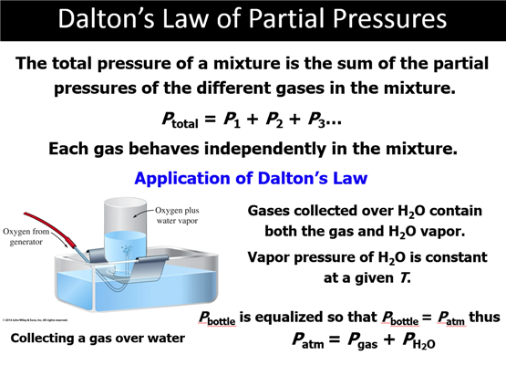

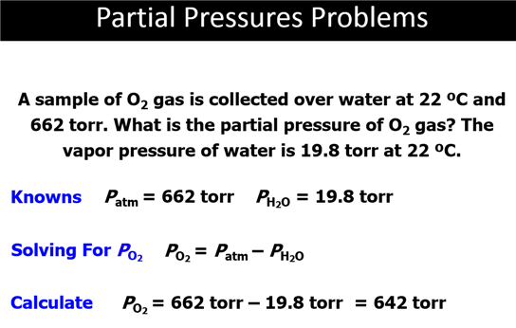

Pathway 2: Chapter 2 Part G D Gas Laws
State:

Boyle’s Law (In words and formula)

Charles Law (in words and formula)

Dalton’s Law of Partial pressures (in words and formula)

Gay-Lussac’s Law (in words and formula)

Avogadro’s Law (in words and formula)

Ideal Gas Equation (write only the equation

Pathway 2/4 Chapter 2 Part G0-G6 Gas Law Problems

Part G0: Gas Pressure Calculations:
State standard conditions (STP) in three units of pressure (the last is your choice) and ºC and K temperatures:
_____mm Hg or ______torre= ______atm = _____ ______(you write the unit too)
_____ ºC = ______K

767 torre = ______atm

Are the values for the Molar Gas Volume Constant:
1 mole _{CO2} =________L _{CO2@STP} 1 mole _{H2} =________L _{H2@STP}
1 mole _{N2} =________L _{N2@STP} 1 mole _{O2} =________L _{O2@STP}
Calculate the Value of R in LxAtm/(Kxmol) using the deal gas equation:

Part G1 Boyle’s Law
1. A sample of a gas has a volume of 100 mL when measured at 25 ºC and
760 mmHg. What volume will the gas occupy at 25 ºC and 380 mmHg?

Part G2: Charles Law
2. The volume of a gas is 100.0 mL at 27 ºC. At what temperature in degrees Celsius would the volume of the gas
be 200.0 mL, assuming the pressure remains constant.

Part G4: Dalton’s Law of Partial Pressures
3. Calculate the dry volume in milliliters of 200 mL of hydrogen gas collected over water at 25 ºC at 760 torre pressure
with the temperature remaining constant. (The partial pressure of water vapor at 25 ºC is 23.8 torre.)

Part G3: Gay-Lussac’s Law
4. A sample of gas occupies 100.0 L at 710.0 torre and 27 ºC. Calculate the pressure in torre if the temperature is
changed to 127 ºC while the volume remains constant.

Part G6: Avogadro’s Law
5. A 1.5 mole sample of a gas occupies 25.0 L at 758 torre and 27ºC. Calculate the Volume of the gas, if more
molecules are injected into the vessel increasing the moles to 2.5 moles, provided the pressure and the
temperature do not change.

Part G5: Ideal Gas Equation-Combined Gas Laws
5. Calculate the number of moles of nitrogen gas in a 5.00 L cylinder at 27 ºC and 4 atm pressure.
R = 0.0821 L atm/ K mole )

How much does this volume of gas weigh?

Part F: Phase Diagrams
Identify the points labeled on the
Phase Diagram of water:
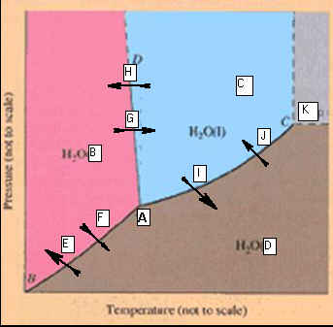

_____________________A.

_____________________B. _____________________H

_____________________C. _____________________I

_____________________D. _____________________J

_____________________E. _____________________K

_____________________F

_____________________G
CHM1025C Module One Homework Packet
Phase Diagram for Carbon Dioxide.
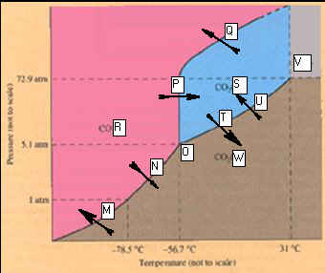

_____________________M. ____________________T

_____________________N. _____________________U

_____________________O. _____________________V

_____________________P. _____________________W

_____________________Q.

_____________________R

_____________________S

Corwin’s Phase Diagram????
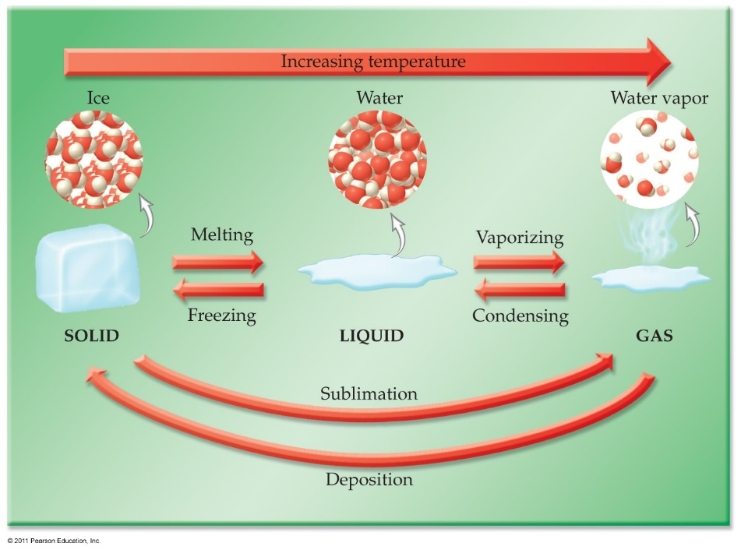
CHM1025C Module One Homework Packet
Part P1: Phase Diagram Applications
1 point
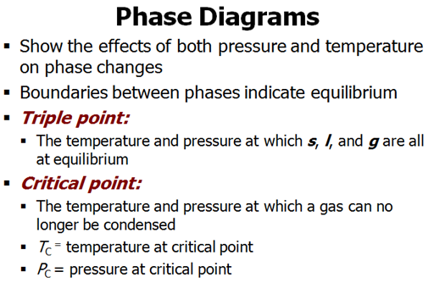
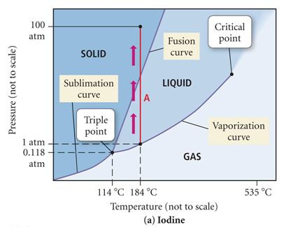
A demonstration of heating iodine in a beaker has purple vapors..can you explain
using the phase diagram above?
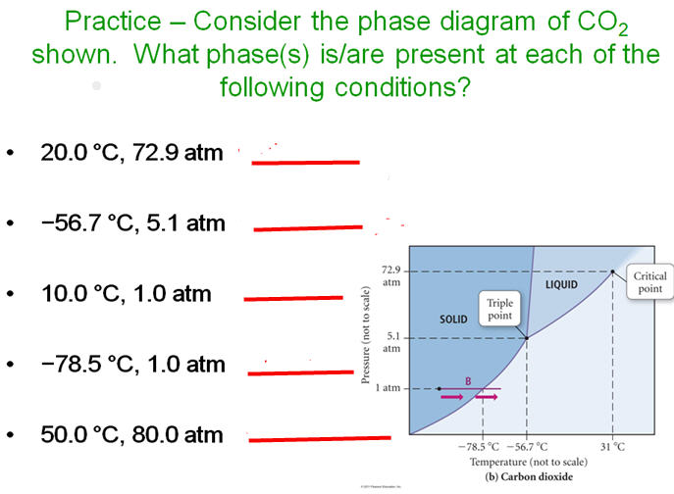

Watch Video:

Real Video Movie (Requires Real Video Plug In):
http://www.fscj.me/PhaseDiagram/01Phase_Diagram.rm1.6 c. Unit Conversion (Conceptual Chemistry 5th Appendix B)
Video #CO106c (5.26 Minutes)
Mobile/Cell Phone Link: http://bcove.me/anfsogbq

Additional Videos Online Menu:
http://www.fscj.me/chm1025/Video/Chapter2VideoMenu.html

Kinetic Molecular Theory-Section 2.8
The gas properties and laws discussed in Chapter 2 are based on the Kinetic Molecular
theory. The CHM 1025C texts list five or six basic assumptions.
You will write these assumptions on the test (red summary)
1. Gases are composed of molecules*^{[1]}. The distance between the molecules
is very-very great compared to the size of the molecules themselves, and
the total volume of the molecules is only a very-very small fraction of the
entire space occupied by the gas. Therefore, considering volume, we are
primary considering empty space. (This assumption explains why gases
are highly compressed and have very low densities.)
(Gases are made up of very tiny molecules. The volume of a gas is mainly
empty space).
2. No attractive forces exist between molecules in a gas. (This is what keeps a gas
from spontaneously becoming a liquid.)
(Gas molecules have no attraction for one another.)
3. The molecules of a gas are in a state of constant, rapid motion, colliding with each other
and with the walls of the container in a perfectly random manner.
(This assumption explains why different gases normally mix completely.
The collisions between molecules and the walls of the container account for the pressure
exerted by the gas.)
(Gas molecules demonstrate rapid motion, move in straight lines, and travel
in random directions.)
4. All of these molecular collisions are perfectly elastic. As a result, the system as a
whole experiences no loss of kinetic energy, the energy derived from the motion of a particle.
(Gas molecules undergo perfect elastic collisions.)

5. The average kinetic energy per molecule of a gas is proportional to the absolute temperature,
and the average kinetic energy per molecule is the same at a given temperature and pressure
for all gases.
(The average kinetic energy of gas molecules is proportional to the Kelvin temperature, that is
KE is approximately T.)
When we think of molecules of elemental gases, we usually think of the diatomic gases such as nitrogen,
oxygen, hydrogen, etc. The Nobel gases exist as monoatomic gases such as Helium, Neon, etc.
These assumptions are sometimes condensed as follows:
(a) Gases consist of particles (molecules or atoms), whose separation is much greater
than the size of the particles themselves.
(b) The particles of a gas are in continual, random, and rapid motion. As they move,
they collide with one another and with the walls of their container, but they do so
without energy loss.
(c) The average kinetic energy of gas particles is proportional to the gas temperature.
All gases, regardless of molar mass, have the same average kinetic energy at the same
temperature.
The assumptions or postulates are summarized on page 47 of Chapter 2

