Projections of the data Collected/Calculated

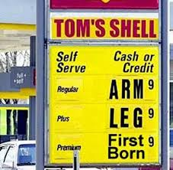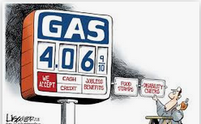
The last part of the project is for you to do the annual projections and summary of CO₂ emissions. This is worth 10 points.
- What is your annual mileage?
Annual Mileage = your daily average miles driven calculated above multiplied by 365 days in a year

- What is your projected annual need for gasoline?
Annual Gasoline Demand = Your average daily Gallons Used multiplied by 365 days in a year

- What would be your annual cost at $2.00 per gallon; $3.00 per gallon; $3.50 per gallon; $4.00 per gallon; $4.50 per gallon; and $5.00 per gallon.
Annual Cost @ $2.00/gallon = Yearly Gasoline Demand(gallons) multiplied by $2.00/gallon

Annual Cost @ $3.00/gallon = Yearly Gasoline Demand(gallons) multiplied by $3.00/gallon

Annual Cost @ $3.50/gallon = Yearly Gasoline Demand(gallons) multiplied by $3.50/gallon

Annual Cost @ $4.00/gallon = Yearly Gasoline Demand(gallons) multiplied by $4.00/gallon

Annual Cost @ $4.50/gallon = Yearly Gasoline Demand(gallons) multiplied by $4.50/gallon

Annual Cost @ $5.00/gallon = Yearly Gasoline Demand(gallons) multiplied by $5.00/gallon
- Total Pounds of Carbon Dioxide released into the atmosphere by you every year.
Total Annual CO₂ Released = Total Annual Gallons Used multiplied by 18.7 pounds/gallon

This experiment is equivalent to four small projects (two wet chemistry labs) as it is an intense A-15/B-12: 10-14 week exercise in data collection or
an intense A-7: 5-7 weeks exercise in data collection
for 20-60 points depending on the number of weeks data is collected.
(If you have two cars, you may do two projects. The second car will earn extra credit. Then you may compare the efficiency or lack of for your fleet of autos. If you change cars during the project, you have to make some estimations-talk with your instructor how to switch cars during the project and maintain the accuracy of the project Although it will be interesting to see if there is a difference between the two vehicles, it still could as only one project. Maybe a little extra credit for presentation.

The chemical reaction for combusting gasoline is:

2 C₈H₁₈ (l) + 25 O₂ (g) 16 CO₂ (g) + 18 H₂O (g)
Octane burns in oxygen gas to form carbon dioxide and water as products ,which comes out your tailpipe
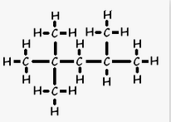 | + |  |  |  | + | 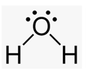
(Burn 1 gallon put 18.7 Lbs CO₂ in the environment!)

In CHM 1025C & CHM 1020 Chapter 9 introduces Mass Stoichiometry.
(In CHM 2045C Chapter 3 begin stoichiometry)
We will prove the 18.7 lb CO₂/gallon statement when we study chemical reactions and mass stoichiometry in Chapter 9.
Do not worry about this Calculation until we get to chapter 9 Section 9.2

Show a dimensional analysis setup in your project to prove this in the conclusion of your project.
Unit Factors Needed: 3.79L = 1 Gal 0.680g C8H18 = 1L 453.56g = 1 lb 1 L = 1000 mL
2.205lb = 1kg 1000g = 1kg 114gC₈H₁₈ = 1 moleC₈H₁₈ 44.0g CO₂ = 1 mole CO₂
*You need to only fill the tank twice, at the beginning and at the end of the project. You will not use the first fill-up in your calculations, except odometer reading. Why?

The instructor may add additional data for you to determine to complete this project after studying chapter 9.
If you do not drive or own a vehicle and can not get cooperation from your family, the instructor will be assigned an alternate energy demand project (My Electric Demand!) or you may earn partial credit using the data of your instructor’s car (4 years instead of 2-5 months).

Project Conclusion/Summary
Write a summary/Conclusions and statement of what you learned from this project (at least one paragraph). In your Summary paper, the data above and below states we are doing better conserving our gasoline while more cars are on the road and the price for the last year or two has dropped 50%! Why? (include a paragraph)
In your project conclusion describe what the octane rating means and what octane you use in your vehicle.
Research the Internet. And see if you can find additional information.
I found the following:
In 2015 the EIA (United State Energy Administration) reported:

How much gasoline does the United States consume?
In 2015, about 140.43 billion gallons (or about 3.34 billion barrels¹) of gasoline were consumed² in the United States, a daily average of about 384.74 million gallons (or about 9.16 million barrels per day).³ This was about 1.5% less than the record high of about 390 million gallons per day (or about 9.29 million barrels per day) consumed in 2007.
¹ There are 42 U.S. gallons in a barrel.
² EIA uses product supplied to represent approximate consumption of petroleum products. Product supplied measures the disappearance of these products from primary sources, such as refineries, natural gas processing plants, blending plants, pipelines, and bulk terminals.
³ Preliminary data for 2015.
We Are Using Less Gasoline Today
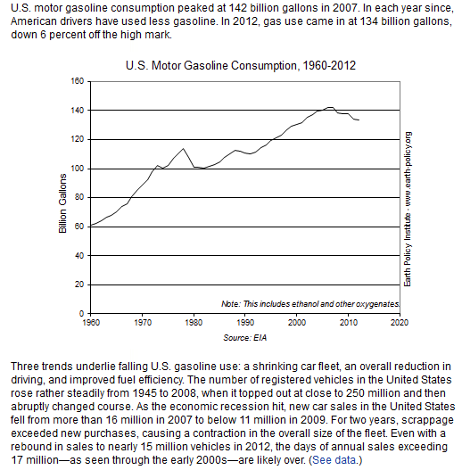
U.S. Total Gasoline Retail Sales by Refiners (Thousand Gallons per Day)

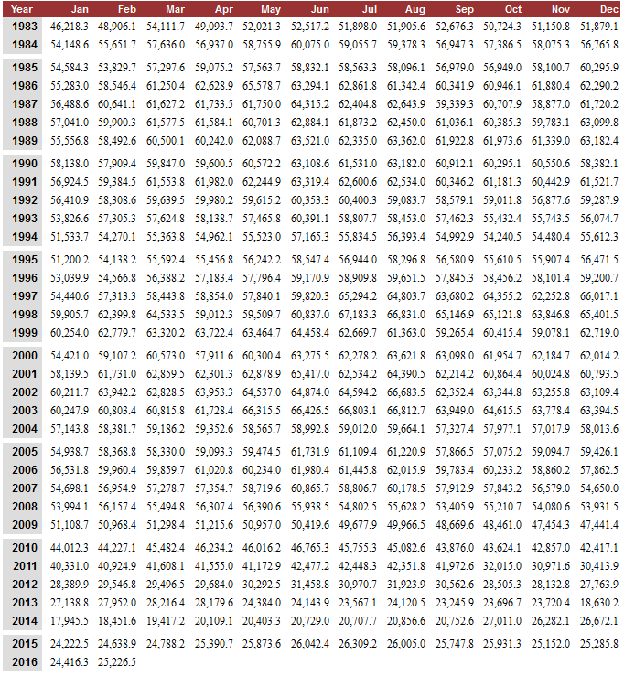

Update of Gasoline Usage in the United States

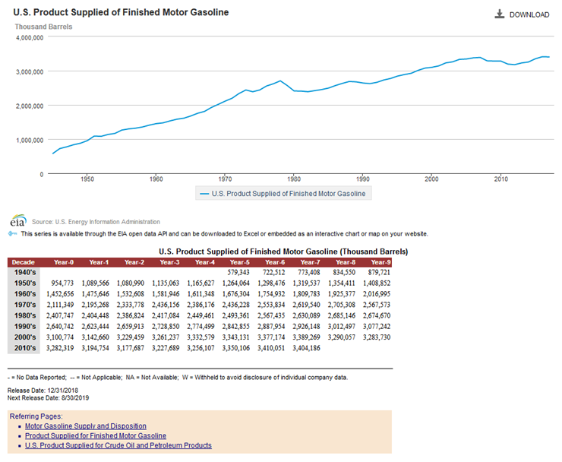URL: https://www.eia.gov/dnav/pet/hist/LeafHandler.ashx?n=PET&s=MGFUPUS1&f=A

Average U.S. gasoline usage lowest in 3 decades, study says (Automotive News March 2015)
With improvements in vehicle fuel economy, U.S. drivers’ average gasoline consumption is the lowest it’s been in at least 30 years, according to research by the University of Michigan released today.
The number of gallons of gasoline used per person, driver, vehicle and household is below rates in 1984, when the study was first conducted, according to researcher Michael Sivak of the University of Michigan Transportation Research Institute.
In 2013, gallons of gasoline consumed per person (392) fell 17 percent from 2004, gallons used per driver (583) fell 16 percent, and gallons used per household (1,011) fell 19 percent. 2004 was the year of maximum consumption for those categories.

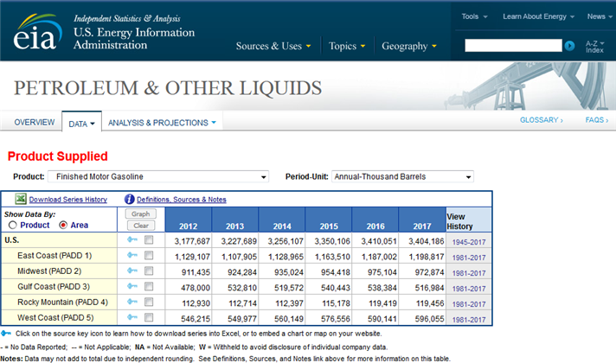

URL: https://www.eia.gov/dnav/pet/pet_cons_psup_a_EPM0F_VPP_mbbl_a.htm

Article Continues:
Gallons used per vehicle (524) dipped 14 percent from 2003, which was its maximum consumption year.
Even though population grew 8 percent from 2004 to 2013, total fuel consumed by light vehicles decreased 11 percent, Sivak said in a statement.
In 1984, annual fuel consumption rates were slightly higher than in 2013: 400 gallons per person, 608 gallons per driver, 602 gallons per vehicle and 1,106 gallons per household.
The study also found that the number of vehicles and distance driven per person, driver, vehicle and household are at their lowest since the 1990s, the statement said.
The declining number is driven not only by economic factors, but also rises in telecommuting and use of public transportation, Sivak said.
“The reductions in the fuel-consumption rates reflect, in part, the added contribution of the improvements in vehicle fuel economy,” he said in a news release.
“Per person, per driver and per household -- we now have fewer light-duty vehicles, we drive each of them less and we consume less fuel than in the past,” Sivak added.
Sivak and fellow researcher Brandon Schoettle also compile an average fuel economy report each month.
Contact Automotive News

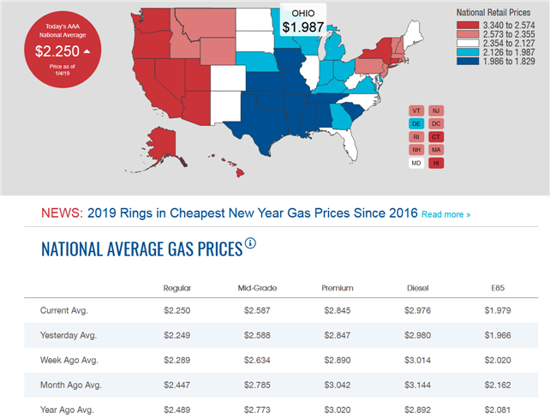
Why do we not add the # gallons and Total Spent
on the initial fill-up in the Project Totals at the
bottom of your data presentation?

How do we determine the #days in the project?
One of the Octane Molecules we will study in Chapter 12
2,2,4 Trimethylpentane
What does this octane rating mean?
In your project conclusion describe what the octane rating means and what octane you use in your vehicle.
Premium: 91-93 Octane Midgrade: 89 octane Regular: 87 octane
Can you buy 100 octane gasoline?

